**S P I R I T**

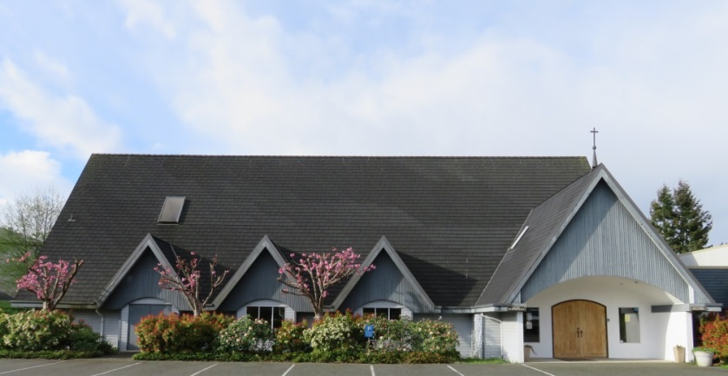

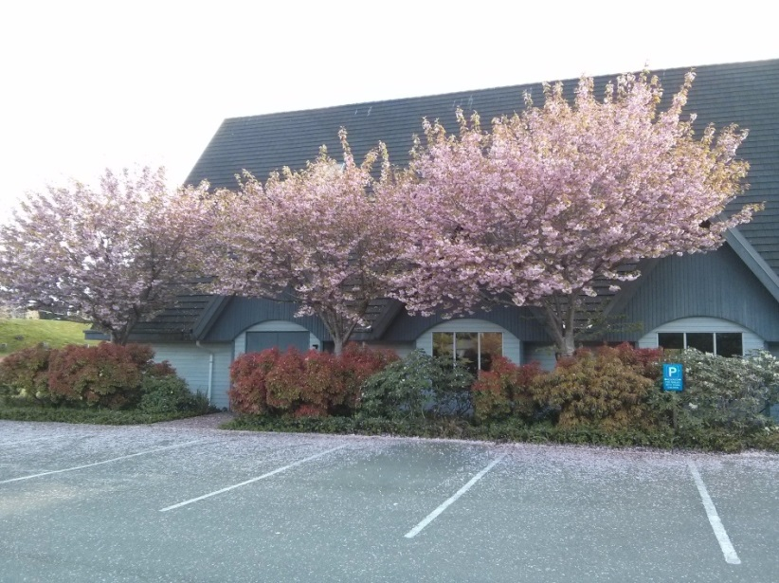St. Peter’s Anglican Church, Campbell River

228 South Dogwood St. Campbell River BC, V9W 6Y7

**Vision Statement:**

**Inspired by God and the example of Jesus to serve our community**

**by offering love and acceptance to everyone.**

September 2017 Issue 3 Editor: Jane Monchak

Interim Priest: Rev. Phil Zimmerman Office: 250-286-1613

Office Administrator: Kerrie Pulford Office: 250-286-1613 Fax: 250-286-1650

Parish Hall: 250-286-9663 E-mail: stpeterscampbellriver@shaw.ca

Website: [www.stpeterscampbellriver.com](http://www.stpeterscampbellriver.com)

Facebook: [www.facebook.com/StPetersCRiver/](http://www.facebook.com/StPetersCRiver/)

**Notes from the Editor:**

Many thanks to all who have contributed to this issue of Spirit. Check out the events of the summer in “What’s Been Happening.”

Welcome to Fall and all that it brings. This issue of Spirit has several events described in the section “What’s Coming Up” and in “Reports” by a number of folks.

And, find out who the “Mystery Parishioner” was in the last issue of Spirit as well as who the new one is in this issue!

**Reports…**

**Chuck’s Chatter**

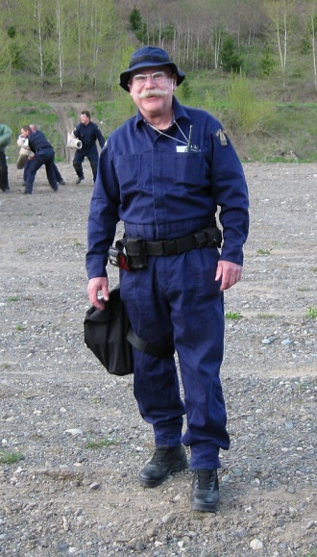In the June 2017 issue of *THE SPIRIT*, inside the last page the editor put a picture of a weird looking character and asked if anyone could identify the individual. Well, that individual was/is me. AKA Charlie Chaplain. Note Chaplain is spelled differently from the movie actor, Charlie Chaplin.

In that picture, I was wearing my black tactical team shirt, my tactical team ball cap, my bulletproof vest and a gas mask. I spent 15 years on the R.C.M.P. Vancouver Island Tactical Troop (VITT) as their chaplain. That meant I trained with them and went on call-outs with them.

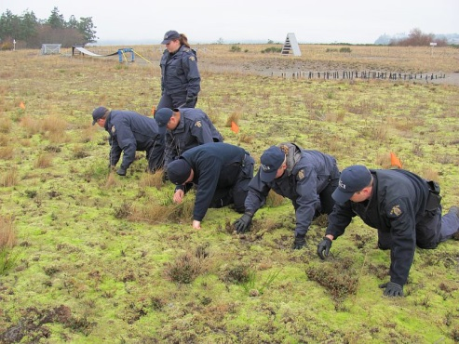At the Summit of the Americas in Quebec City in April of 2001 there was an extremely major riot lasting several days. Riot squads from all across Canada were there and were all called into action. After the Vancouver Island unit got back west, their leader went to the commander of the district and asked if they could have a chaplain on the team. The boss asked if they had anyone specific in mind and the team leader mentioned my name. The rest, as the saying goes, is history. News media have covered these political riots from Quebec to Seattle to Atlanta to England to Europe to Greece to South Africa to Australia et al. Police units have to be prepared to be called out on a moment’s notice to deal with such events. Most are political in nature, but sometimes they are local in nature like the Stanley Cup Riots in Vancouver a few years ago.

In response to a riot, the command vehicle travels close on the back end of the responding team. Those in the vehicle must be geared up for all possible situations. Since the vehicle is up close to the front line, tear gas can and will filter into the unit. Riots are a very, very small part of what the Tac Team does. They also get involved in recovery operations. They are called out for VIP security protection operations and are called in the event of major evacuations such as the Kelowna fires of a number of years ago or the Fort McMurray fires or they prepare for future events like the Port Alberni tsunami of a few decades back.

One of the major roles of the Tac team is called "Search and canvas." VITT is one of the world leaders in this activity. The VITT trains units across Canada, the US, and has been involved across the Atlantic. This involves such things as grid ground searches looking for the minutest bit of evidence, and/or canvassing door to door in an area asking appropriate questions looking for evidence or information. There is a knack to doing this properly.

In 2010, they spent five weeks at the Olympic venues in Vancouver and Whistler searching and securing the same. I was lucky enough to spend those five weeks in Whistler.

In everything the team does, the word TEAM is terribly important. There is no room for individual activity. It is all done as teamwork. In a major event, every member must be aware of what the other team folks are doing and where they are and know that they are all equally capable and trained. Everyone looks out for the well-being and safety of each other. VITT has members from all detachments on the island as well as from Powell River. The team has its own medical staff and ambulance. It has a forensic ident member.

Oh yes we have dogs, too! Why the command post is called

The dogs are not the least BIG BLUE, I’ll never know.

bit bothered by gas.

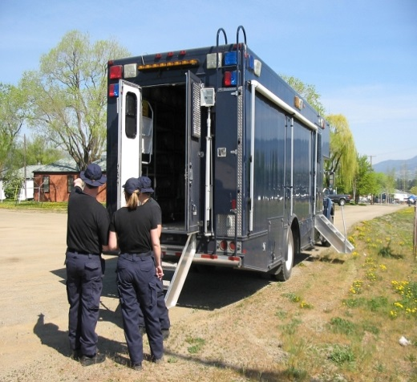

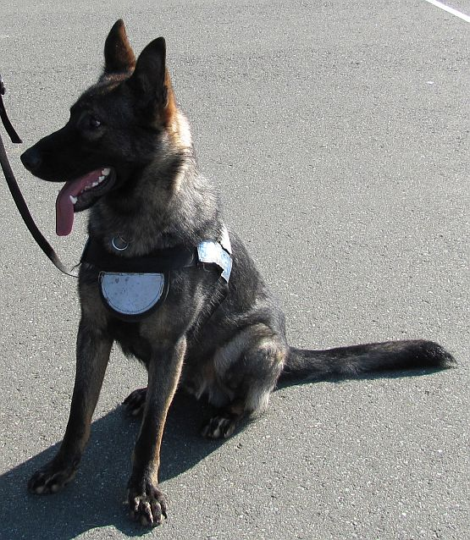

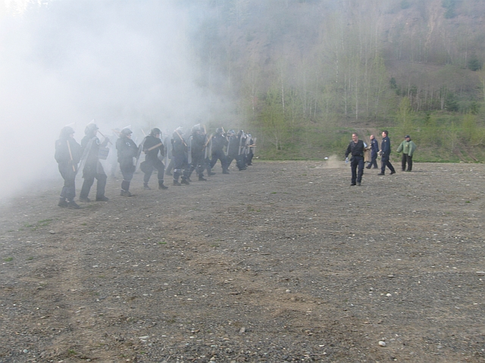Three pictures (one at the beginning of the article) of me at the gas range. The first was photo-shopped by one of our members who knew I had a liking for cats.

**The Spirit of Finance - September 2017**

As we enter the fall season, I would like to say “thank you” to those of you who have kept up the faith and business of the church, are planning future fundraising events and are working to find a new minister for us.

I have been away most of the beginning of the summer and then have had company in August and early September. It makes the time go very, very quickly. Jill was busy getting a son married off along with everything else that she does, so I am sure that the summer went quickly for her as well.

Our finances look to be quite healthy as of the end of August. We had a bank balance of $30,775.67. We are showing a net income of $2957.32 which makes me very happy even though we are nearly $3,000 under our budgeted income from Envelopes General and Special Offerings. We will continue to monitor our income and expenses, look forward to our fund raising events and enjoy the seasons to come.

Your sisters in Christ,

Holly Finn and Jill Cook

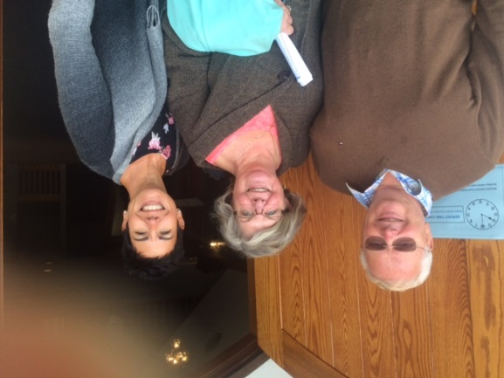**Warden’s Report**

Let us begin by saying “Thank You” to the many that support our community of St. Peter’s. Welcome to new members. The summer has been quiet in the parish on a day-to-day basis. We have been busy keeping the garden watered and weeded. Sandy Barnes has been very helpful with recycling. Numerous people helped with vacuuming and dusting. Phil has been busy with Yuculta, Berwick, Evergreen and Wednesday and Sunday services. Kerrie and Dan were on vacation from the end of July to the first week of August.

The Parish women enjoyed a morning of fellowship and a delicious breakfast at the On-Line Café in July. Thank you to both Pam Hedderson and Crystal from the cafe for your organization. Is there anyone who would like to organize the Women’s Christmas breakfast?

Parish council enjoyed a scrumptious BBQ hosted by Bill Ritchie in August. We are in the process of selecting a Parish Retreat Day in September or October. The focus of the retreat is: Communication.

Each of us have been able to spend time away on vacation and are now looking forward to the fall schedules. As usual, St. Peter’s is a busy place. We welcome Reverend Brooke Mitchell to St. Peter’s. We also look forward to her leading a book study on Thursday afternoons on the book by Rowan Williams; Being Disciples: Essentials of the Christian Life. Other events to look forward are the “Timeless Treasures Sale” on Saturday, September 23 with thanks to Jennifer Coolen for coordinating it and a Spaghetti Dinner on Sunday, September 24 with thanks to Hadley and Sandra for organizing it.

On Sunday, September 10, six of us from St. Peter’s spent a wonderful day at St. Saviour by-the-Sea on Cortes Island. We thoroughly enjoyed the scenic trip. Humpbacks said hello and goodbye. It is a picturesque little church, beautiful stained glass and a welcoming congregation.

Remember there is suggestion box in the Narthex to put your ideas in as we move forward with selecting a new priest.

As we write this report, Pauline and Cathy are attending the “We Together” conference in Victoria. 140 people are expected to attend the two-day event. Jane Jennings will be facilitating a workshop on Mindfulness at the conference. We look forward to this incredibly rich and rewarding time in our spiritual and faith journeys. Again, our contact information is on the back of the bulletin.

Have a wonderful fall. Blessings, Pauline, Bill and Cathy.

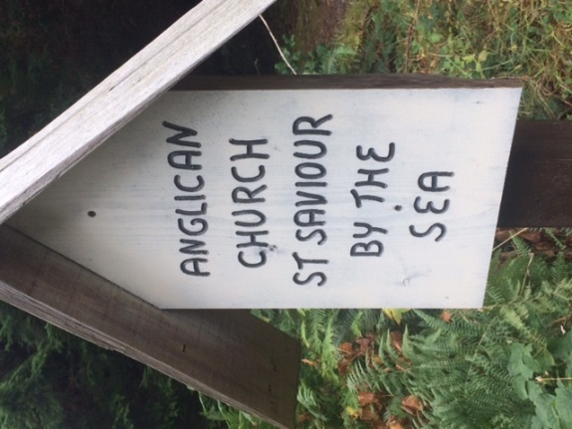

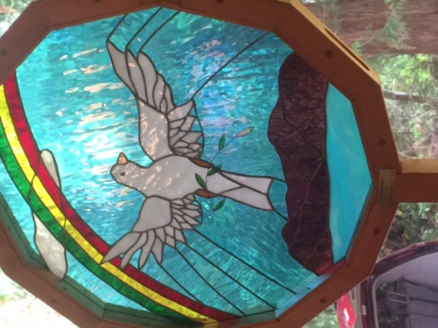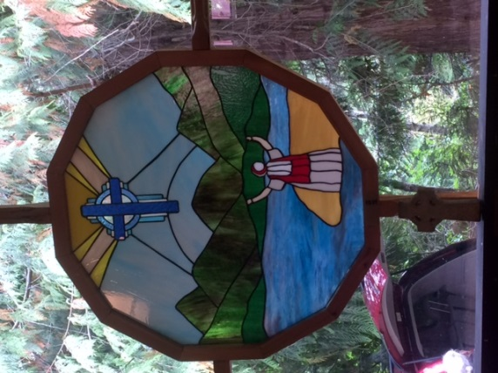 Stained glass windows at St. Saviour by the Sea, Cortes Island

**Library Report - Browse and borrow**

We have over one thousand books in our Library!  Plus DVDs.  Whether you want non-fiction, or adult or children’s fiction, there are lots to choose.  Come to St. Paul’s room whenever the church is open.  The library is available to anyone, not just church members, and the borrowing period is three weeks.  Here you will find we use the Dewey Decimal system, just like the public libraries.  Shelves are labeled; in non-fiction, you will see Religion at 200, Bibles at 220, and so on.  Librarians are in on Mondays, 9.30 a.m. until noon.  We hope to have a library assistant in the library on Sundays after the service, too.

The church archive has records of historical events in the life of this congregation.  See Joan Palmer for access to the archives.

**Choir Notes**

Choir practices are Friday afternoons from 3:00 p.m. to 4:00 p.m. If you love to sing, come out and join our choir director, Brock Lupton and the choir.

**What’s Been Happening…**

**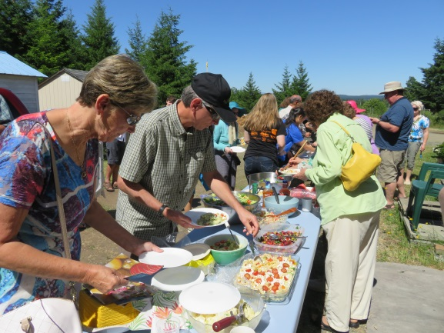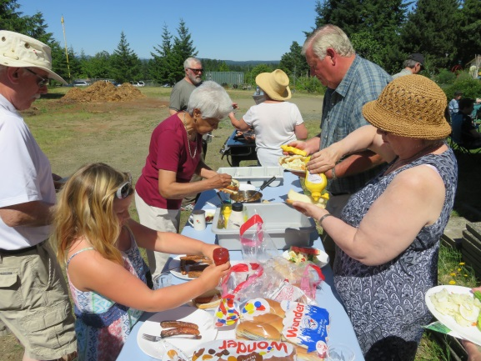St. Peter’s Parish Picnic – Sunday, June 25, St. Peter’s Church Garden**Worship, fellowship, fun and food; a great combination for a successful parish picnic. The Syrian Newcomer Family was able to join us too!

**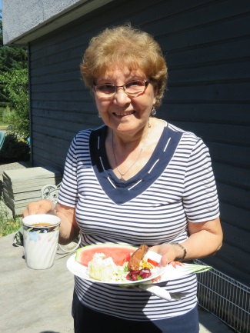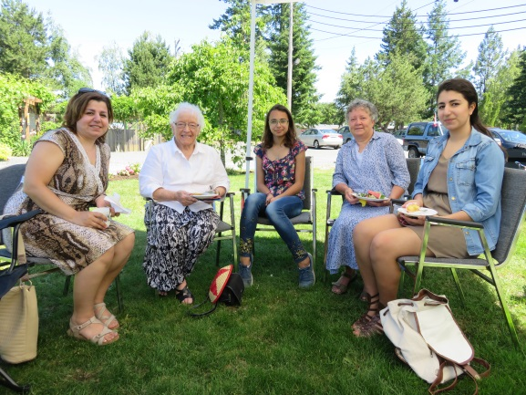**

**Summer Sunday School**

**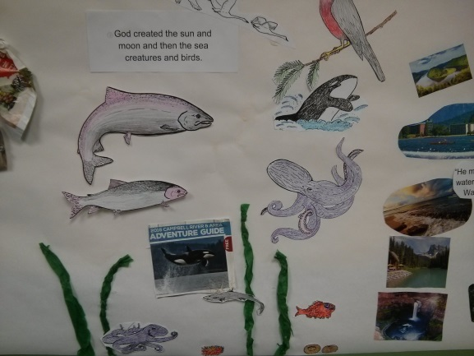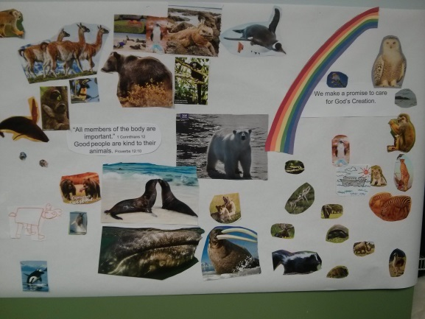**Many thanks to the volunteers who prepared to teach this year’s Summer Sunday School. The story of creation was told through a narrative in this Sunday school resource. Contents included background and guidance for teachers, activities and stories to promote stewardship of the environment. Ryan the Rhino helped with the telling of the story.

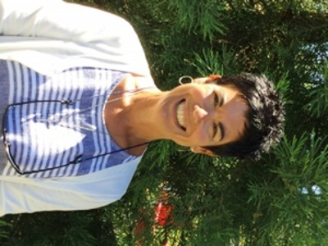**2017 We Together Diocesan Conference Reconciliation**

Held at Christ Church Cathedral on September 15 and 16, 2017, I had no idea of the spiritual impact these two days would have. Cathy Beise and I had a beautiful, sunny drive to Victoria and attended the wine and cheese reception at the church followed by the Opening Eucharist at 7:00 p.m.  There were approximately 135 people attending this conference. The “sermon” by keynote speaker Michelle LeBaron, a UBC Professor of Law, and Director of the program Dispute Resolution, gave a very powerful presentation on Reconciliation and Conflict – A Relationship Process. Cathy and I left that evening overwhelmed and hearts full of new thoughts and ideas.

Saturday was workshop day, opening with Keynote Speaker Adam Olsen, Green Party of B.C., MLA for Saanich North and the Islands.  He was raised on the Tsartlip First Nations in Brentwood Bay. He discussed his family history, their connection to the land, waters and creatures and his goals of building relationships between First Nations and municipal governments.  It was as very heartwarming and informative speech.

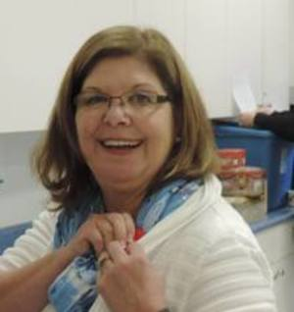The workshops included three sessions throughout the day and you could choose what interested you most.  Cathy and I first attended “Stewardship of Creation” led by Elizabeth May, who is Leader of the Green Party of Canada as well as an environmentalist, writer, activist and lawyer. What a woman with an amazing past and so much concern for our future! We thoroughly enjoyed our session with her and her wonderful sense of humour.  We learned so much and we realize we have a lot to do to save our planet! Our second session was “Healing Oil” led by Bishop Logan. He spoke about the meaning of the oil, what we use it for and asked us what it meant to us.  Wonderful thoughts, stories and questions were asked; and he anointed those of us who wanted healing for ourselves, or for someone in our hearts.  He played “Come Healing” by Leonard Cohen for us, which brought tears to my eyes.  If you have not heard it, please do! We had a lovely lunch break at noon. Our last session of the day was “Dismantling Racism” led by Patrick Sibley, Reverend at The Church of St. John the Divine. We did not realize how much racism occurred in Canada starting in the 1500s; strong in the late 1800s and strongest in the 1900s.  There is so much that was never taught in schools, which was never discussed in our homes and was never publicized.  What a revelation that was! I suggest you Google racism in Canada; choose a time-period and see what you get.  You might be very surprised. The hard truth is that there will always be racism no matter how hard we try to change it.

The Conference closed with a wrap-up and sending-forth with prayer and thanks.  Cathy and I came home with renewed hearts, renewed spirits and a renewed people.

 Save the date for next year’s conference on September 28-29, 2018.  They hope to have it in Nanaimo or Parksville. We know we will be attending and hope many of you will too!

Blessings,

Pauline Woods and Cathy Biese

A link for “Come Healing” by Leonard Cohen is below. Control and click to follow the link if you are reading this on internet. <https://www.youtube.com/watch?v=MUB1O2cT2gM>

Spirit Editor

**What’s Coming Up…**

**Time Change for Sunday Service – September 10**Starting September 10, we are back to the 10:00 a.m. time for the service. Announcements are after the Processional Hymn at the beginning of the service. Sunday School and Nursery are provided during the service.

**Sunday School Start-up – September 10**Regular Sunday School classes started on September 10. We continue to use a new curriculum that we began using last year. It is “Whirl Lectionary.” We use a lectionary-based program because it follows the readings that are used each week in the 10:00 a.m. service. Please look at the following link to learn a little more about the curriculum.<http://wearesparkhouse.org/kids/whirl/lectionary/>There are two classes:  Pre/K to Grade 2 – teachers are Keith and JaneGrades 3 to 6 – teachers are Diana and \_\_\_\_\_ .  Yes, Diana needs a partner.   
Youth (Grade 7 and up) will meet once a month with Chuck, on the last Sunday of the month, for a Bible Study. On the other three/four Sundays, youth are welcome to stay in church; sign up to help in either classroom or the Nursery; sign up on the Servers List. Registration forms are available in the Narthex. Please be sure to fill out the form and leave it with one of the Sunday School teachers or in the Sunday School mail slot in the hallway by the photocopier. We need the information for our records and the Diocese office requires us to send information on numbers of children who are registered for Sunday School.We look forward to this year.  
 Jane Monchak, Diana Hicks, Sunday School Coordinators

The Whirl Bunch – Victor, Ada, Otto, Tatiana, Montgomery and friends  
(from Sparkhouse website)

[**St. Peter's Supports Grassroots/Kind Hearts**](http://www.stpeterscampbellriver.com/news/st-peters-supports-grassroots-kind-hearts) **– Third Wednesday each month**

Please keep Grassroots Kind Hearts in your thoughts and prayers as this organization looks for a permanent shelter for the upcoming fall and winter. If you would like to help prepare a menu item for this Outreach Program, (September 20, October 18, November 15) please, sign up on the list at St. Peter’s, leave your name at the office at 250-286-1613 or contact Diana’s e[mail at stpeterscampbellriver@shaw.ca](mailto:stpeterscampbellriver@shaw.ca). To learn more about the Grassroots/Kind Hearts program or St. Peter’s Anglican Church, please visit: [St. Peter's Outreach Programs](http://www.stpeterscampbellriver.com/ministries/outreach-programs). <http://www.stpeterscampbellriver.com/ministries/outreach-programs> Trina Soltys

**Saturday Morning Crafters – last Saturday in October**

Come for some fun, fellowship and crafting – with the Old Fashioned Christmas Bazaar in mind. Learn a craft to “make and take” and make one to donate to the bazaar. The presenter

provides the supplies for a flat rate of $5.00 per person. Yes, coffee and tea are on!

Monday, September 25 – Jane will demonstrate Quilted Christmas Balls**. The date and time for this craft is Monday evening, September 25, 7:00 p.m.**

Saturday, October 28, 9:00 a.m.–Noon – Sherry will demonstrate a Snowman hat Christmas decoration using recycled K-cups.

Please email Jane at [monchak@shaw.ca](mailto:monchak@shaw.ca) if you plan to attend either of these craft sessions.

**A Safe Church Up-date**

Good news! The revised Safe Church training program is now ready and sessions are being offered in the diocese. Several of our parishioners have attended a new session and found it to be good – clear, to the point and interesting. The sessions now take 3 hours (instead of a full day) and are good for 5 years (instead of 3).

Current schedules are posted on the bulletin board between the Narthex and the Hall and the Fall sessions are listed below. Please note that pre-registration is necessary to attend a session and contact numbers have been included. Many of the sessions are being offered down island but there are October sessions in Qualicum and Courtenay that some of you may be able to attend. We have offered to host a session here in Campbell River but no date has been set. Once we have a date it will be posted on the bulletin board, announced in church and posted on websites etc. At the time of writing this is the Fall schedule:

Sept. 20 10 a.m. Salt Spring Island (250) 537-2171

Sept. 23 9 a.m. Christ Church Cathedral (250) 383-2714

Oct. 3 6 p.m. St. Barnabas, Victoria (250) 383-5888

Oct. 14 9 a.m. St. Andrew, Sidney (250) 479-7250

Oct. l8 1 p.m. St. Marks, Qualicum Beach (250) 752-5414

Oct. 21 9 a.m. St. John’s, Courtenay (250) 334- 4331

Those who need to renew their Criminal Record Checks in 2017 have already been given the forms to fill in and take to the RCMP station. Once you get them back, please drop them off at the Church Office. Just a reminder, the Synod Office requires original forms with St. Peter’s identified as the organization for which you are volunteering. As it tends to take longer to get checks back in the Fall it would be a good idea to take them in soon!

If you’re not sure whether you need to attend a training session or renew your Criminal Record Check please contact me (250) 286-6634 or see me at church – I try to remember to have my lists with me!

**Spaghetti Dinner – Sunday, September 24, 5:00 p.m.**

Hadley is organizing another “molto bene” Spaghetti Dinner! We hope you have signed up so you do not miss out.

**We Together Youth – October 1**

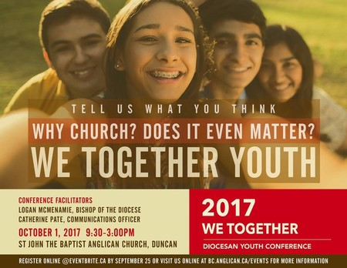I recently sent you an invitation to an October 1 event I am hosting for youth of our diocese. Some of you have already begun responding to that invitation. Thank you.  Attached is a poster with details of the gathering and registration details.

We Together Youth is an opportunity for young people between the ages of 12 and 18 to come together and talk about the role of the church in their lives.  We know that many youth are not attending Sunday worship during these formative years, or engaging in the other ministries of their local parish, and I want to know why.  I also want to know how the church can play a role in their formation, even when attending worship does not seem to fit.

Please share this electronic invitation with the youth in your community and [register](https://www.eventbrite.ca/e/we-together-youth-diocesan-conference-tickets-36666213632?aff=es2) yourself, along with two young people from your community to attend this free event by **September 25.**   I am looking forward to listening to what the youth of our community have to say. ***Bishop Logan***

**Fall Book Study – Thursdays, October 5 through November 9**   
 1:00 p.m. – 2:30 p.m., in the Church library  
Discussion Leader: The Reverend Brooke Mitchell  
You are invited to join us for a book study this fall based upon Archbishop Rowan Williams’ book,  *Being Disciples: Essentials of the Christian Life*. Archbishop Williams is the former Archbishop of Canterbury of the Anglican Church.  We will be reading a chapter each week, coming together for discussion, then finishing with a time of prayer.    
The cost of book is $15.00 (or, if you prefer, download via Kindle for $9.99) Please sign up by September 10 so that we may order the books.  The sign-up sheet is on the Hallway bulletin board.  We need a minimum of six people to form the group.

**St. Peter’s Book Sale - October 20-21**

Dust off the books you no longer plan to keep on your bookshelf, sort them into fiction and non-fiction, box or bag them and please bring them to the hall at St. Peter’s the week of Monday, October 16.If you love to sort and organize, or if you just love books, this is the fundraiser for you! So come out the week of October 16 and help us sort before the sale. Of course, sign up to help the day of the sale. Please watch for sign-up posters on the hallway bulletin board. If you would like more information, please speak to me. Jane Monchak

**St. Peter’s Old-Fashioned Christmas Bazaar – November 24-25**

At this year’s bazaar, we will be featuring pickles, relishes, anti-Pasto and other canned goods. The processing requires sterilizing, so is food safe. If you are doing some home canning, please donate to the table; it is certainly be appreciated. We will feature jams and jellies as they were a big hit at our August sale.

Please keep in mind, if you have any items for the Christmas table or Collectables table those items (including jewelry),will be graciously accepted. Watch for opportunities where you can participate, beginning in October. We could sure use some help stirring your love into the Christmas cakes, as well as cooking, cutting, and wrapping the cakes for a nice presentation at the bazaar.

As this is a parish function, the more you get involved the more you get out of it. For those who may not be aware, all the funds raised are turned over to the church. Last year we cleared over $10,000, which goes towards expenses, and commitments our parish makes. Fellowship, stewardship and a great sense of satisfaction as well as lots of fun go towards making this another event to look forward to.

Should you have any questions, please feel free to give me a call. (250-923-8108)

Lois Tirebuck

**Advent Quiet Day – Expectations Saturday, December 2, 2017**

10:00 a.m. – 2:30 p.m.

St. Peter’s Anglican Church in the Library

Facilitator – Margaret Shea, Spiritual Director

Come away for some peace and quiet before the frenzy of Advent and Christmas activities begin in earnest. Come away and prepare your heart and soul as we await the coming celebration of the birth of our Lord Jesus Christ. What are your expectations of the season and of the New Year? Let's explore our hopes and dreams for the future.

*In the depths of your hopes and desires*

*lies your silent knowledge of the beyond;*

*and like seeds dreaming beneath the snow*

*your heart dreams of spring.*

*Kahlil Gibran, The Prophet*

We begin the day with an abbreviated Morning Prayer including a short Centering Prayer/Christian Meditation sit, followed by our first reflection. You will have a time of silent contemplation on the reflection where you can take a walk outside, sit in the sanctuary, journal, read, or in whatever action the Spirit calls you. After a brief time of sharing, fellowship and lunch, we will begin our afternoon with a second reflection and more quiet time. We will end our day with a wrap up and Closing Prayer.

Please bring your Bible and journal if that is your custom and a bag lunch. Coffee, tea and snacks provided.

For more information phone Margaret at **250-287-3704** or email at [**margshea147@hotmail.com**](mailto:margshea147@hotmail.com). There will be a sign-up sheet in November on the bulletin board.

****

**Articles of Interest…**

**Prepare for Next Year’s Plant Sale - Plant Winter Protection**

Here are some of the things I do every fall in my garden.

1) Water as frequently as possible and scatter small amounts of fertilizer around to help strengthen roots on my perennials.  
2) I use fertilizer spikes for fruit trees and flowering shrubs.  
3) I fertilize my rhododendrons and azaleas with their food; 10-8-12.  
4) I cut back perennials in fall: Peonies, Lilies and Hostas. Cut back peonies after the first frost when the leaves go brown.  
5) It is better to wait until spring to cut back most perennials especially the ones planted this year. Top growth traps the snow on plants protecting them and providing moisture and insulation.  
6) I dig up my Dahlias after first frost.  
7) Fertilize my cedars & lilacs with their food; 18-4-8

Remember last year’s freezes and thaws which followed each other so suddenly? Most perennials have trouble with this because the roots and crowns of the plants dry out. This causes winterkill. Mulching in exposed areas helps protect your perennials.

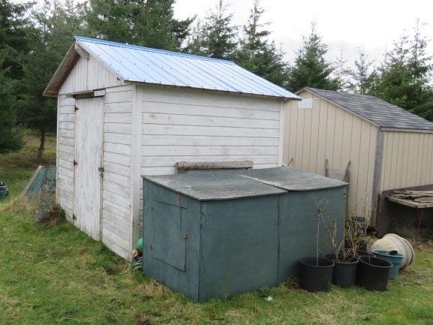These are some ideas for fall garden care. Glenna Armitage

**Pots Needed for the Plant Sale**

Unless you need pots to pot up plants, bring them to the old shed behind the church. We will need them for next year. Save the date; next year, St. Peter’s Plant Sale is May 5, 2018.

Spirit Editor

**New Commemorative Pole at the Campbell River Museum**

**In Memory of Samuel Henderson**

It was a great privilege to hear the stories and legacy of Samuel Henderson at the unveiling of the replica thunderbird bear pole carved by his son, master carver, Bill Henderson, and grandson Junior. It was important that this pole be carved, as it was a tribute to Samuel Henderson; an inspirational role model for his many descendants, in carving, life skills, traditions and most of his descendants attended the pole raising. Bill also spoke of the good relationship Samuel had established with the people and local town council of Campbell River.

There was much drumming, dancing, and singing by several groups; engaging informative speeches that told of their family traditions, culture and legacy of replacing a pole. They told how the original pole, carved by Samuel in 1966 for the BC Centennial in 1967, now needed to be replaced, was taken to the beach, ceremonially burned and released to the waters.

After the raising of the pole, the air was filled with downy white feathers as the drumming and dancing and blessing of this family legacy continued. Several chiefs spoke words of wisdom and blessings.

After the ceremony, the public were invited to a delicious luncheon prepared by the Henderson women early that morning. It was a very memorable and educational day for many in the life of the Henderson family. Barbara Henshall

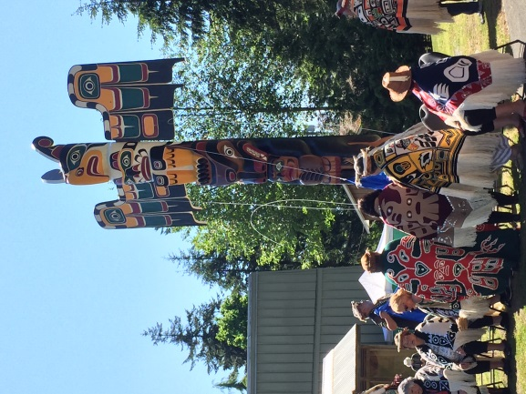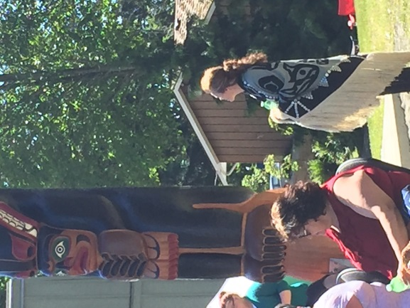Photo (left) of Ann Jordan wearing her late partner, Mark Henderson’s Mother’s blanket.

Photo (right) of the thunderbird and bear pole as it was unveiled. The Elder Women danced and later sat in front of the pole.

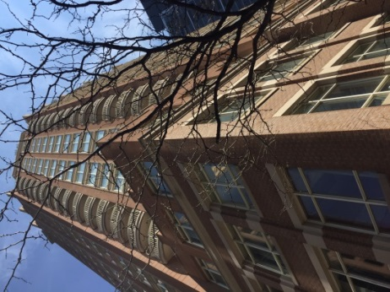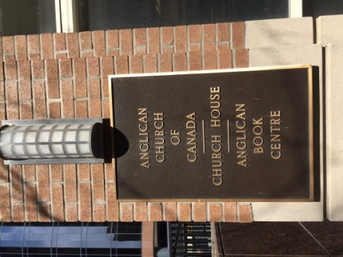

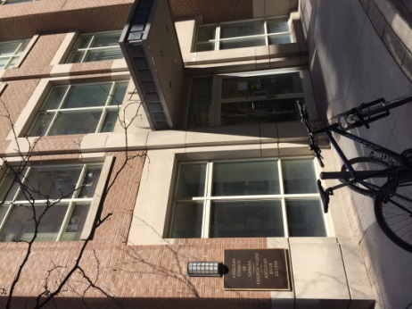Photos of “Church House” the National headquarters of the Anglican Church of Canada.

**Worshipping at St Saviour- by-the-Sea, Cortes Island**

**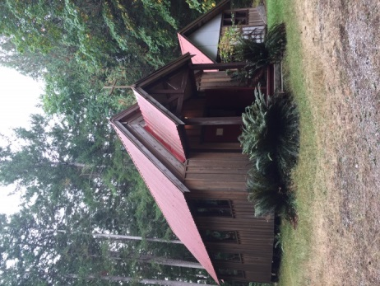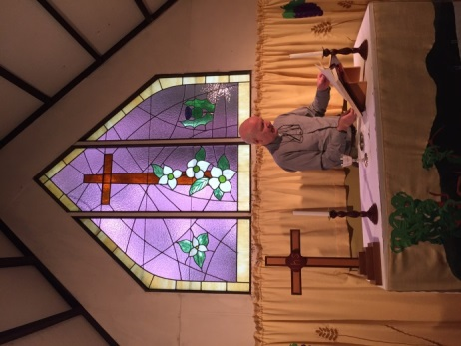**As part of the regular ministry of the priest of St. Peter's, Phil Zimmerman travels to our sister parish, St. Saviour, on Cortes Island once a month.  Five of us travelled with him this past Sunday, September 10, 2017. On both sailings between Heriot Bay and Whaletown we were delighted to see orcas breaching in the waters. Who needs a whale-watching tour when we have the BC Ferries!  
We were welcomed with a humble little sign in the forested area, “Anglican Church, St. Saviour by the Sea.” As we travelled up the curving gravel road, the smell of an ancient cedar, the dry firs and the smoke wafted from a beautiful old wood stove. There was a great sense of peace with nature as we explored the grounds and church; a special place, a holy place in the midst of the towering firs. Locally made, beautifully crafted stained glass windows adorned each window. A newly built outhouse was available behind the church. The congregation was delighted that their numbers has swelled to 14 that day.  
After the more simplistic service, as many have a diversity of backgrounds, parishioners provided very welcome coffee and cookies for all. Because the water is not potable, the women had brought several jugs of water for the coffee.

As we waited at the ferry to return to Campbell River we sat on the beach amongst the arbutus trees with their peeling bark watching the waves lap against the shore and later at a little park a very tame deer that had been eating apples in an abandoned orchard greeted us. There was a great sense of peace and simplicity in this time and on this day. We greatly enjoyed meeting or renewing friendships of the peoples of St. Saviour, our brothers and sisters on Cortes Island who we pray for every Sunday at St. Peter’s. Barb Henshall

**Announcements…**

**MCSY01650_0000[1]**

**Baptisms**

Bradley William Woehry May 19 2017

Georgia Grace Amaya Hayes July 25 2017

Desmond David West Hayes July 25 2017

Austyn Raili Ann Vig July 29 2017

Paytin Leaman July 29 2017

Hunter Stephen Michael Kingstone July 29 2017

**Weddings – none**

**Confirmations – None**

**Deaths**

Fredrick Lloyd Ivan June 15, 2017

Hugh George Rombough June 20, 2017

**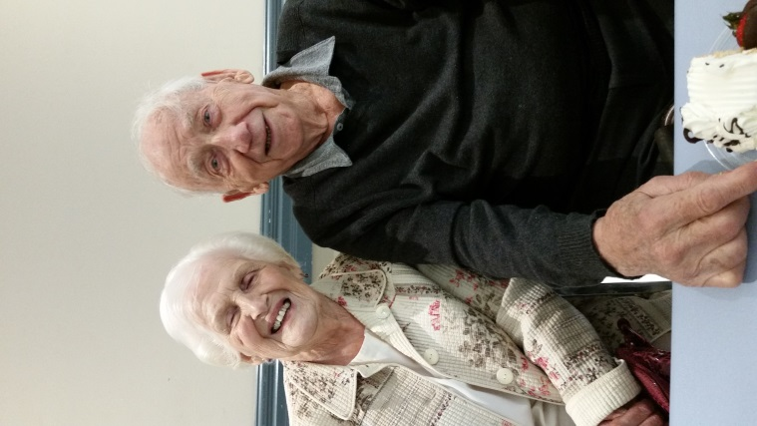Happy 100th Birthday, Ed!**

Ed Hartwell celebrated his 100th birthday with his family and St. Peter’s at coffee hour on September 10. We all enjoyed the cake!

Happy birthday to you,

Happy birthday to you

May God bless you and keep you

Another year through!

**Mystery Parishioner!**

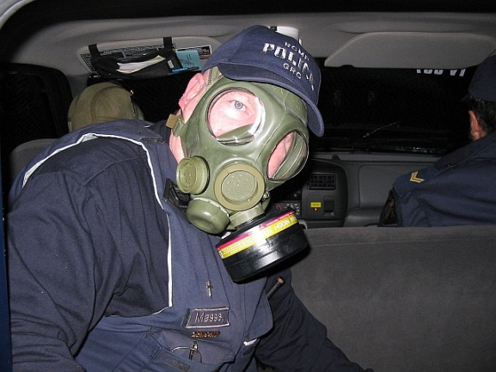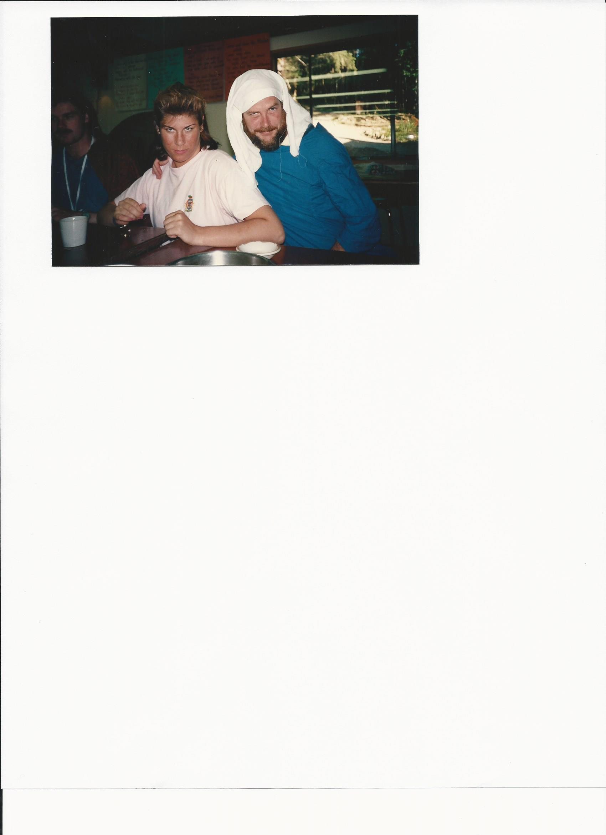Did you guess the Mystery Parishioner in the June issue of Spirit is Reverend Chuck Massey? (on the left).

See “Chuck’s Chatter for an explanation for this picture.

Now, can you guess the new Mystery Parishioner for this issue? (on the right).

**Campbell River Family Caregivers Meeting** - **October 16, November 20**The Caregivers October meeting has a special guest: Christie Simon, nurse practitioner with the Vancouver Island Health Authority who has a particular interest in supporting Family Caregivers. Come share your experiences, concerns and thoughts.  Get help navigating the healthcare system and get your questions answered.  Lots of free information and resources are available.  Confidentiality is assured.  Support Groups are facilitated by retired Campbell River Nurses and supported by Family Caregivers Society of British Columbia.

**Time**:    2:00 pm to 4:00 pm

**Where**: Ironwood Place – 1351 Ironwood Street, (across from Campbell River Common Mall)

All welcome to attend. If you would like more information, please speak to Pam Hedderson.

**Weekly Schedule at St. Peter’s**

MONDAY: 9:30 a.m. – Noon Library   
 7:00 p.m. – 9:00 p.m. Bible Study

WEDNESDAY: 10:00 a.m. – Noon ACW

12:10 p.m. Noon Day Eucharist

4:00 p.m. – 4:45 p.m. Mindfulness as Spiritual Practice Group

FRIDAY: 3:00p.m. – 4:00 p.m. Choir Practice

**Other Monthly & Occasional Activities at St. Peter’s**

1st Tuesday of the Month Eucharist at Yucalta Lodge at 3:00 p.m.

1st Wednesday of the Month Eucharist at Berwick at 1:30 p.m.

1st Thursday of the Month Hymn Sing, Evergreen Seniors Home at 10:30 p.m.

3rd Thursday of the Month Parish Council Meeting 7:00 p.m.

2nd Sunday of the Month Service at St. Saviour’s, Cortes Island

4th Sunday of the Month Service alternating between Yucalta (2:00 p.m.)

and New Horizons (2:00 p.m.)

**Notable Future Dates (Mark your calendars):**

We Together at Christ Church Cathedral September 15 - 16

Nimpkish Regional Meeting September 23

We Together Youth October 1

Timeless Treasures Garage Sale September 23

Harvest Supper Saturday October 14 (tentatively)

Book Sale October 20 - 21

St. Peter’s Christmas Bazaar November 24 – 25  
Advent Quiet Day December 2   
Christmas Pageant December 17 (tentatively)

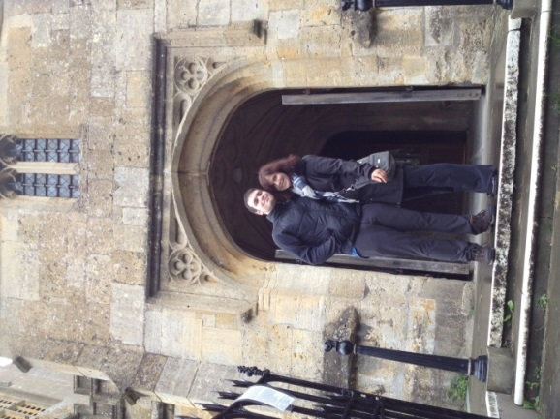

Iain and Diana at St. Peter's.

Winchcombe, the Cotswolds, England.